NOARLUNGA CITY
OBEDIENCE DOG CLUB INC

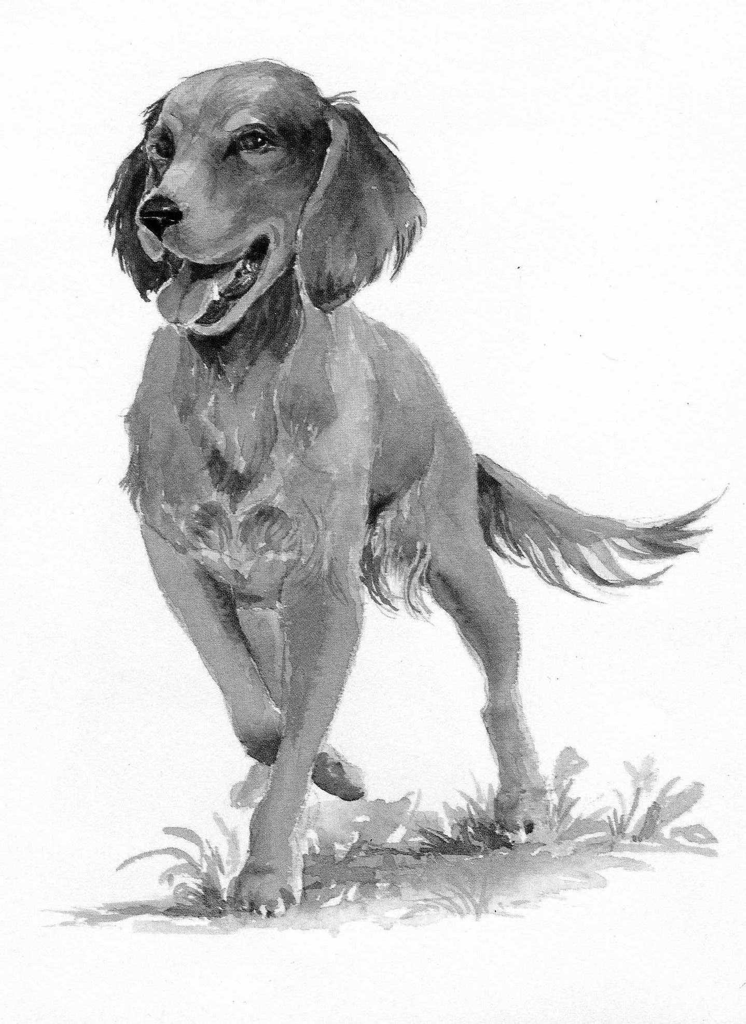
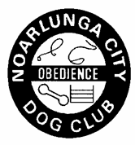

OBEDIENCE

TRIAL

13TH JUNE 2015

NOARLUNGA CITY OBEDIENCE DOG CLUB INC
OBEDIENCE TRIAL

SATURDAY 13TH JUNE 2015 AT 10.00AM
PIMPALA PRIMARY SCHOOL, VANSTONE AVENUE,

MORPHETT VALE

TRIAL CLASSES JUDGES
CCD ROS KUMELA
NOVICE JAN BRABHAM
OPEN DARRELL MOSS
UTILITY ANNE TWADDLE
UDX ROS KUMELA

VETTING TIME: 9.15AM - 9.45AM - BITCHES WITHOUT PROOF
OF DESEXING. ALL DOGS TO PASS THROUGH
CHECKPOINT BY 9.45AM.

TRIAL MANAGER: BRIAN FIELDER
SACA REP: RAE HEDGER
ORDER OF JUDGING: ALL RINGS SIMULTANEOUSLY. UDX
BEFORE CCD.

TROPHIES: 1ST IN EACH CLASS – QUALIFYING ONLY.
OTHER AWARDS: PRESIDENT’S SHIELD TEAM EVENT.

PLACE CARDS: 1ST, 2ND AND 3RD IN EACH CLASS
SASHES: ALL QUALIFYING ENTRIES

This trial is conducted under the Rules of the South Australian Canine Association.

CATALOGUE PREPARATION

Every effort has been made to ensure that the placement of multiple entries does not
cause conflict with other classes entered.

If any alterations need to be noted in marked catalogues please see the Secretary prior
to the conclusion of the trial. Marked catalogues are available on the Dogs SA Obedience
website - www.dogobediencesa.com.

PRESIDENT’S SHIELD TEAM TROPHY RULES

Team to consist of three entries from any class except CCD. Entry fee - $1 per dog.
i.e. $3 per team.

CCD JUDGE: ROS KUMELA

1. J RAGUGINI KLIMKIE TIA 58W/D
SDK&ODC ROTTWEILER
REG NO 5100076194

2. J HUGHES CH WALDWIEZE GRAEVELVET AT POSHVWEI
MULTI SAODC (IMP NZ) RN SCR
GDCSA WEIMARANER
REG NO 02054-2013

3. V WESTBROOK TOTACHI LOKI 90PTS
MULTI SDK&ODC BORDER COLLIE
REG NO 2000849830

4. G CRUSE HOTPAWS RUBY-STAR 5W/D
AMERICAN STAFFORDSHIRE TERRIER
REG NO 5100071927

5. S HANKS CUJO 42W/D
BORDER COLLIE
500997AR

6. DJ NEEDHAM & ELEMENTAL LORD JIM (AI) 57W/D
MULTI L MCDONALD LABRADOR RETRIEVER
SAODC REG NO 5100068100

7. A NATION QUOVADIS LOTSA CHARM RN 97PTS
MULTI GSDC GERMAN SHEPHERD DOG 1ST PLACE
REG NO 5100078830

8. P KOLECKI BONNIE 94PTS
NCODC AUSTRALIAN KELPIE X 2ND PLACE
501005AR

9. I MURRELL ALPENHUND POSEIDON TDX SCR
HANDLER: K MURRELL BERNESE MOUNTAIN DOG
REG NO 5100076036

10. T WALKER BUNDARRAH OPUS 88PTS
GCDTC CAVALIER KING CHARLES SPANIEL
SAODC REG NO 2100362680LR

11. R VAN DER LINDEN WALLACE 90PTS
NCODC CAVALIER KING CHARLES SPANIEL/PUG X
500999AR

CCD cont. JUDGE: ROS KUMELA

12. H HEDGER HAMISH RN 0W/D
NCODC BORDER COLLIE/AUSTRALIAN KELPIE X
500938AR

13. C EDWARDS ZACH 45NQ
PDODC HEELER X
500946AR

14. I & D PYE KERDEN ROB ROY 86PTS
FDOC BOSTON TERRIER
REG NO 4100228228LR

15. E SPACIE CHARLIE 63W/D
SDK&ODC SPOODLE
500986AR

16. J JONES RIMINI WILD CHILD 89PTS
NCODC SHETLAND SHEEPDOG
REG NO 5100075384

17. DJ NEEDHAM & ELEMENTAL LADY JANE (AI) 91PTS
MULTI L MCDONALD LABRADOR RETRIEVER 3RD PLACE
SAODC REG NO 5100068103

18. C KOCH CH WINTERBOURNE IRISH LEGEND 54W/D
SAODC JACK RUSSELL TERRIER
REG NO 5100062720

19. S REYNOLDS TESS 74NQ
FDOC LABRADOODLE
50991AR

20. C CORNWELL TYKERNA FREDA 69NQ
SDK&ODC ROTTWEILER
REG NO 5100072515

21. J SMITH GILARISHA UPTOWN GIRL SCR
GERMAN SHEPHERD DOG (LSC)
REG NO 5100032985

22. JJ SULLIVAN TOOKURRA MIDNITE PASSION RN JD 88PTS
NCODC BORDER COLLIE
REG NO 5100066701

CCD cont. JUDGE: ROS KUMELA

23. J PENGELLY JENDALLY THE POWER OF ONE 86PTS
SDK&ODC DALMATIAN
NCODC REG NO 3100274063

24. A GILBERT BENJI 67W/D
TERRIER X
501002AR

NOVICE JUDGE: JAN BRABHAM

25. J LYON ALBAJAIL BEN MAC DHUI AD JD CCD 188PTS
HANDLER: T MCDONALD AUSTRALIAN SHEPHERD 2ND PLACE
SDK&ODC REG NO 5100073092

26. U SHUGG VALHERU HIGHWAY STAR CCD RA AD JD
NCODC HAVANESE 89NQ
REG NO 5100005127

27. J CORBETT BARADAV UNDER THE STAR CCD 174PTS
GOLDEN RETRIEVER
REG NO 5100074950LR

28. S COMBER SILVASOUTH SOUTHERN DAKODA 170NQ
SDK&ODC ENGLISH SPRINGER SPANIEL
REG NO 5100079047

29. R VISSER ROADSEND BLUE WITHOUT YOU 142NQ
SDK&ODC AUSTRALIAN SHEPHERD
REG NO 3100278429

30. IA POWELL WILDERBLU SWEET LOVE 171PTS
FDOC BORDER COLLIE
REG NO 5100071420LR

31. J HUGHES CH WALDWIEZE GAME KEEPA AT POSHVWEI
MULTI SAODC (IMP NZ) CCD RN SCR
GDCSA WEIMARANER
REG NO 02061-2013

32. J DEANE CESTON FRAULEIN ‘A’ ‘Z’ CCD SCR
GERMAN SHEPHERD DOG
REG NO 5100058682

33. J COPPOLA & P GALE KARLSKIND HOPE VON LIZZIE SCR
MULTI SDK&ODC GERMAN SHEPHERD DOG
REG NO 51000473138

34. L KOTZ AUSTRALITE DEVINE SAPPHIRE CCD 144NQ
SCHNAUZER MINIATURE
REG NO 4100210566

35. J BROWN ASHER CCD RE ADX JD GD SD SPDX 94NQ
MULTI SAODC HTM.S DWDF.S
DGK&OC PAPILLON/SHETLAND SHEEPDOG X
500808AR
NOVICE cont. JUDGE: JAN BRABHAM

36. H RANDALL TUSCAMADA BRONZE AUSSIE 162NQ
AUSTRALIAN SHEPHERD
REG NO 5100056168

37. K BURTON CHICO 133NQ
SDK&ODC MALTESE X
500834AR

38. A NATION QUOVADIS LEIGE LORD RN CCD 195PTS
MULTI GSDC GERMAN SHEPHERD DOG 1ST PLACE
REG NO 5100078822

39. S & E KOLZE TOPSPOTT FIREY RING CCD ADM ADO 145NQ
JDM JDO SD GD ET
DALMATIAN
REG NO 5100043278

40. E & J HOPKINS ALISTE AMORETTE CCD 187PTS
DGK&OC SHETLAND SHEEPDOG 3RD PLACE
REG NO 5100075589LR

41. A RAILZ SHELDOW STEAL A HEART 174PTS
SAODC SHETLAND SHEEPDOG
GCDTC REG NO 5100072146

42. J STORR TEDDY CCD RN 119NQ
SDK&ODC POODLE/GOLDEN RETRIEVER X
500993AR

43. P HANSBERRY OZZIE CCD RA SCR
KKDOS AUSTRALIAN KELPIE
500873AR

44. D SUMSION EDDIE JD 90W/D
DGK&OC COLLIE X
500909AR

45. J BROWN COLLIESTON RHYTM AND RHYME CCD RN
MULTI SAODC ROUGH COAT COLLIE SCR
DGK&OC/GCSA REG NO 5100078200

OPEN JUDGE: DARRELL MOSS

46. A MCKENZIE OC CALANAIS ONE FINE DAY ADM JDM
MULTI SDX GDX SPDX 130W/D
BORDER COLLIE
REG NO 5100033137 468MM

47. C BILNEY KOBE CD 85W/D
SDK&ODC TOY POODLE
500854AR 245MM

48. M JOLLEY KOTERANA ROHA CD AD JD 155NQ
DGK&OC CAIRN TERRIER
REG NO 3100272422 308MM

49. DA & HD QUEMARD TREULIEBE DISCO DANCER CD 0W/D
NCODC SCHNAUZER (MINIATURE)
REG NO 5100042314LR 350MM

50. A FARNDELL SCOTSDREAM SNOW STORM CDX TD 70W/D
SAODC SHETLAND SHEEPDOG
REG NO 2100372987 380MM

51. R TURNBULL SHELSIAN EVER SO CLEVER CD RN 68W/D
DGK&OC SHETLAND SHEEPDOG
FDOC REG NO 5100046134 430MM

52. DM & G SMITH GLENTRESS ISLAY CD RN AD JD 176PTS
DGK&OC BORDER COLLIE
REG NO 3100256513LR 465MM

53. S & M REYNOLDS CALANAIS ME AND MY SHADOW CD RE 178PTS
MULTI SDK&ODC BORDER COLLIE
REG NO 5100074311LR 470MM

54. D FRENCH VIKEYSON KEIKO CD 70W/D
SAODC KEESHOND
REG NO 5100055685 470MM

55. S WHITE AULDBRIG TOUCH OF TIGER CDX 87W/D
NCODC BORDER COLLIE
REG NO 2100262101 470MM

56. E ALLEN SHELSIAN CROSS COAST UD RE SCR
SHETLAND SHEEPDOG
REG NO 5100040521 470MM

OPEN cont. JUDGE: DARRELL MOSS

57. A MCKENZIE DUAL CH OC CALANAIS KINKY BOOTS 179PTS
MULTI ADO ADM JDM JDO GDX SPD SDX RAE 2ND PLACE
BORDER COLLIE 475MM
REG NO 5100040202

58. L MCKENZIE QUINORA PLAY WITH FINNESSE CD RN 101NQ
DGK&OC BORDER COLLIE
REG NO 2100069218 480MM

59. J LAVERS STAR CD 152NQ
NCODC AUSTRALIAN KELPIE
S500824AR 480MM

60. AR & JM CULLEN WHYTEWOOD NELLIE BELL CD 109NQ
MULTI DALMATIAN
REG NO 3100293124 540MM

61. J BROWN COLLIESTON KENTUCKY SAGE CDX RAE ADX
MULTI SAODC ADO JDX GD SDX SPDX DWDF.S HTM.S 167NQ
DGK&OC ROUGH COAT COLLIE
GCSA REG NO 5100044440 540MM

62. V WESTBROOK TOTACHI SHOCK WAVE CD 91W/D
MULTI SDK&ODC BORDER COLLIE
REG NO 2100255252 495MM

63. S & M REYNOLDS OC MOLLY RE ADX JDX 136W/D
MULTI SDK&ODC BORDER COLLIE
500618AR 495MM

64. R TREBILCOCK AMBLESPRING MOET CHANDON CD 35W/D
NCODC ENGLISH SPRINGER SPANIEL
REG NO 5100052526 500MM

65. D MCCULLOCH O GR CH AG CH GABRIELLE ADM JDM 179PTS
MULTI DGK&OC ADO JDO SDM GDM DWDF.S RE SPDM 3RD PLACE
PDODC GERMAN COOLIE
500614AR 500MM

66. B KEPLER WILDERBLU TRI RESISTING ME CD RN 185PTS
NCODC BORDER COLLIE 1ST PLACE
REG NO 5100067231LR 510MM

OPEN cont. JUDGE: DARRELL MOSS

67. B TUSAR TUSERA WRATTON BABE CD 83W/D
SDK&ODC LABRADOR RETRIEVER
REG NO 5100066601 545MM

68. R KOWAN KARLI CD SCR
STAFFORDSHIRE BULL TERRIER X
500860AR 560MM

69. AR & JM CULLEN OC TOPSPOTT JETSETTER 176PTS
MULTI DALMATIAN
REG NO 5100031121 580MM

70. J COPPOLA & P GALE KARLSKIND LEADING LADY CD 138NQ
MULTI SDK&ODC GERMAN SHEPHERD DOG
REG NO 5100049373 620MM

71. J BROWN COLLIESTON VIRGINIA WOOF CD RAE 6W/D
MULTI SAODC ADX JDX GD SDX SPDX DWDF.S HTM.S
DGK&OC ROUGH COAT COLLIE
GCSA REG NO 5100044439 520MM

UTILITY JUDGE: ANNE TWADDLE

72. C CREEK TOPSPOTT TENNESSEE TWO CDX JDX
NCODC ADX FDX ET RN 28W/D
DALMATIAN
REG NO 500043270 630MM

73. R BRAUER NUGGETT CDX RN ADX JDX GD SD 86W/D
NCODC AUSTRALIAN KELPIE
500782AR 540MM

74. M HAYLES MISHKA UD RE 102W/D
BORDER COLLIE
500846AR 535MM

75. D MCCULLOCH O GR CH AG CH GABRIELLE ADM JDM 192PTS
MULTI DGK&OC ADO JDO SDM GDM DWDF.S RE SPDM 1ST PLACE
PDODC GERMAN COOLIE
500614AR 500MM

76. C HUTCHINS KAYLADENE BLAZE OF GLORY CDX 151NQ
MPDOC JD AD RN
PDODC BORDER COLLIE
REG NO 3100196456LR 500MM

77. A MCKENZIE DUAL CH OC CALANAIS KINKY BOOTS 183PTS
MULTI ADO ADM JDM JDO GDX SPD SDX RAE 2ND PLACE
BORDER COLLIE
REG NO 5100040202 475MM

78. J BALCOMBE WINDYGLEN PENNY BLACK CDX 21W/D
SAODC BORDER COLLIE
DGK&OC REG NO 5100051761 470MM

79. P FICKLING TCH LASSIE UD TSD RE 0W/D
DGK&OC BORDER COLLIE
500495AR 460MM

80. K MORALEE & JE HILLIER AGCH HILLANI KAISIAS PLAY ET CDX JDM
GDCSA JDO ADM ADO SPD SDX GDX 52W/D
ADCSA POODLE MINIATURE
REG NO 5100039415 413MM

81. D HAYNES JEDDA CDX 126NQ
SDK&ODC POODLE MINIATURE
500713AR 383MM

UTILITY JUDGE: ANNE TWADDLE

82. A FARNDELL SCOTSDREAM A MINUTE IN TIME CDX TDX
SAODC ADX JD PT 156NQ
SHETLAND SHEEPDOG
REG NO 2100315655 364MM

83. A SPEHR TAISON’S PRETTY IN PINK CDX 27W/D
SDK&ODC POODLE MINIATURE
REG NO 5100042674 350MM

84. A MCKENZIE CH CALANAIS BEYOND THE RAVE CDX 107W/D
MULTI ADX JDM GDX SD SPD RN
BORDER COLLIE
REG NO 5100050527

UTILITY EXCELLENT JUDGE: ROS KUMELA

85. M VASEY OC AGCH JILARU ADM JDM ADO JDO 149 W/D
PDODC SPDM GDM SDM
MPDOC AUSTRALIAN CATTLE DOG/BORDER COLLIE X
ADCSA 500360AR

